Extreme Networks ExtremeXOS Virtual Machine with VMware ESXi

Installation Guide

**Abstract:** This document provides a step-by-step instructions for installing and running the ExtremeXOS VM image on VMware ESXi

Published: August 2015

Extreme Networks, Inc.   
145 Rio Robles  
San Jose, California 95134  
Phone / +1 408.579.2800  
Toll-free / +1 888.257.3000

[www.extremenetworks.com](http://www.extremenetworks.com)

© 2012–2015 Extreme Networks, Inc. All Rights Reserved.

AccessAdapt, Alpine, Altitude, BlackDiamond, Direct Attach, EPICenter, ExtremeWorks Essentials, Ethernet Everywhere, Extreme Enabled, Extreme Ethernet Everywhere, Extreme Networks, Extreme Standby Router Protocol, Extreme Turbodrive, Extreme Velocity, ExtremeWare, ExtremeWorks, ExtremeXOS, Go Purple Extreme Solution, ExtremeXOS ScreenPlay, ReachNXT, Ridgeline, Sentriant, ServiceWatch, Summit, SummitStack, Triumph, Unified Access Architecture, Unified Access RF Manager, UniStack, XNV, the Extreme Networks logo, the Alpinelogo, the BlackDiamond logo, the Extreme Turbodrive logo, the Summit logos, and the Powered by ExtremeXOS logo are trademarks or registered trademarks of Extreme Networks, Inc. or its subsidiaries in the United States and/or other countries.

sFlow is the property of InMon Corporation.

Specifications are subject to change without notice.

All other registered trademarks, trademarks, and service marks are property of their respective owners.

For additional information on Extreme Networks trademarks, see [www.extremenetworks.com/company/legal/trademarks](http://www.extremenetworks.com/company/legal/trademarks).

PART# 121102-00

Initial

Initial

**Summary**

This document provides instructions on how to create, install and run an ExtremeXOS (EXOS) virtual machine (VM) on VMware ESXi 5.x

The EXOS VM running in ESXi simulates a Summit series switch with the following virtual hardware features:

* 256 MB flash for OS images configuration and policy files
* 256 MB of memory
* One out-of-band management port
* Up to nine front-panel ports

**Prerequisites**

* Server running VMware ESXi 5.x or greater

VMware ESXi is a bare-metal hypervisor that is available for free as well a paid advanced version (via a licensed upgrade). The EXOS VM will run in both versions.

The latest ESXi installation files including installation instructions can be downloaded from <https://my.vmware.com/web/vmware/downloads>

* EXOS ISO image (e.g. exospc-xx.x.x.x.iso)

This EXOS ISO image file is a bootable CD-ROM image that can be used as a virtual installation CD with a variety of virtual machine applications.

The EXOS ISO image can be downloaded from

<https://github.com/extremenetworks/xkit>

|  |
| --- |
| Note |
| The EXOS ISO image file should be downloaded to a local drive. This file needs to be uploaded to the VMware Host datastore for use during the installation |

**EXOS VM ESXi Installation**

1. **Create New Virtual Machine**

From the Inventory view in vSphere Client click on the “New Virtual Machine” to initiate the “New Virtual Machine” wizard

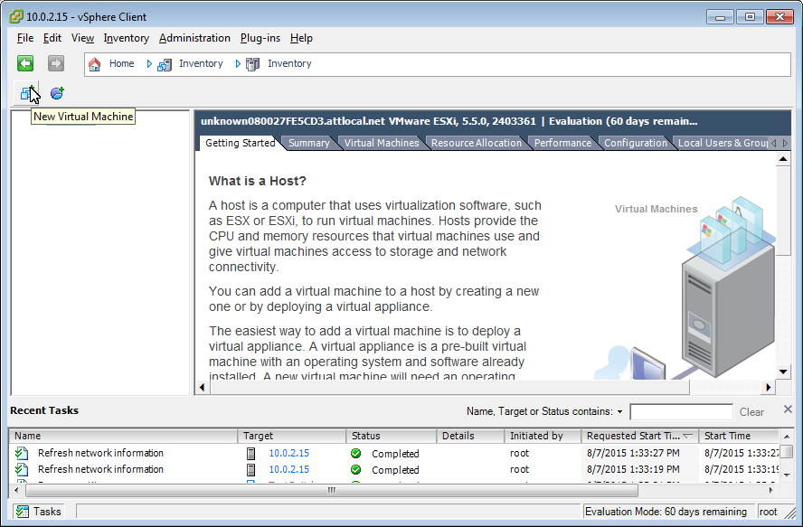

1. **Configuration**

In the “Configuration” pane select “Custom” and then click “Next”

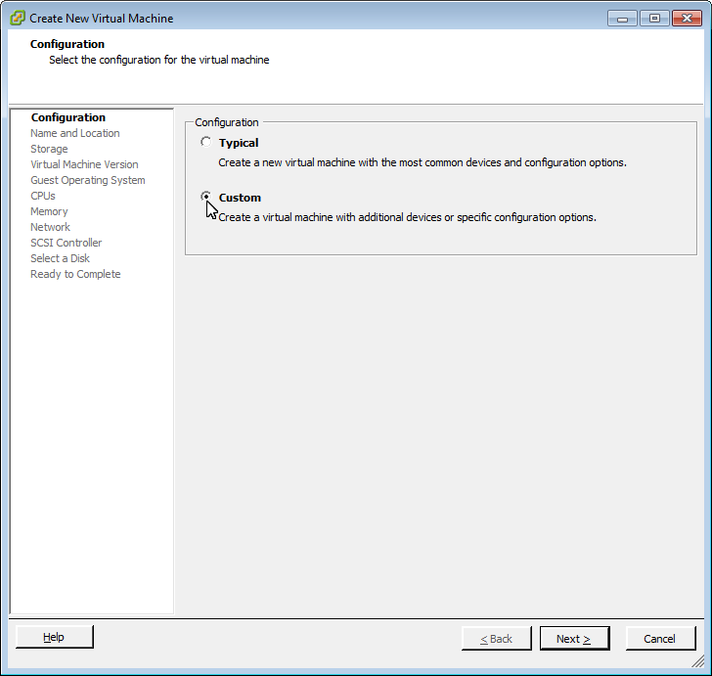

1. **Name and Location**

In the “Name” field enter a name for the VM and click “Next”

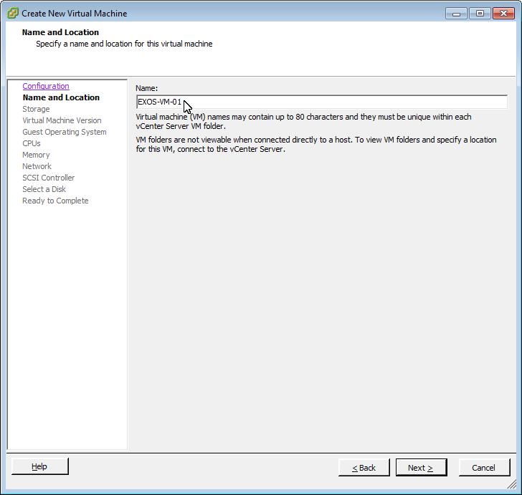

1. **Storage**

In the “Storage” pane select a datastore where the VM will be stored and click “Next”

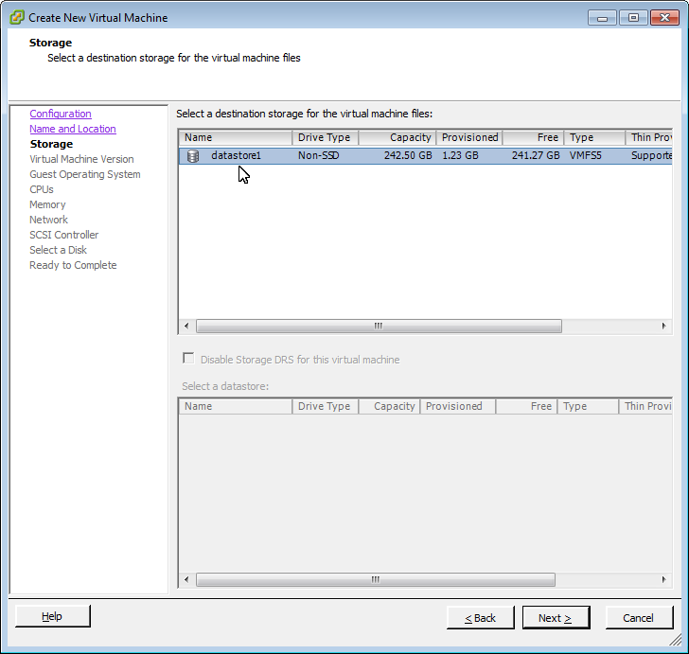

1. **Virtual Machine Version**

Click “Next” to accept the default “Virtual Machine Version: 8” VM version

|  |
| --- |
| Note |
| Virtual Machine version 7 can be used if required |

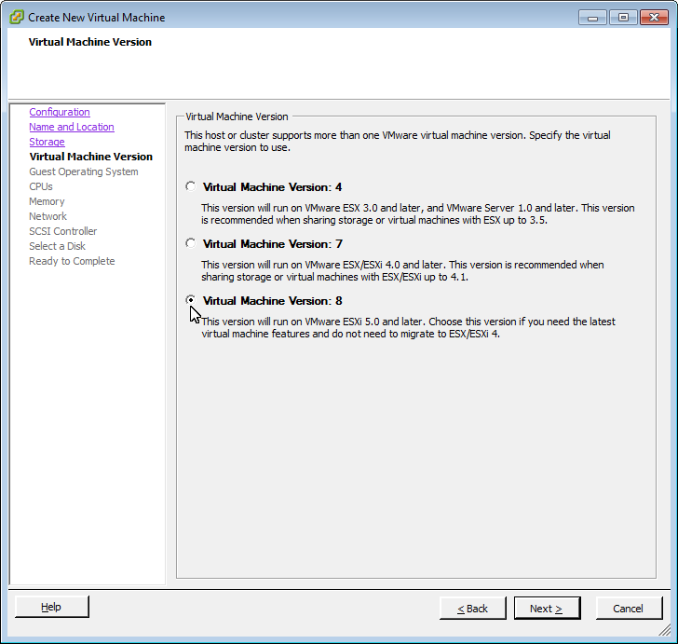

1. **Guest Operating System**

In the “Guest Operating System” panel select “Linux”, and then select “Other Linux (32-bit)” from the “Version” pull down menu, click “Next

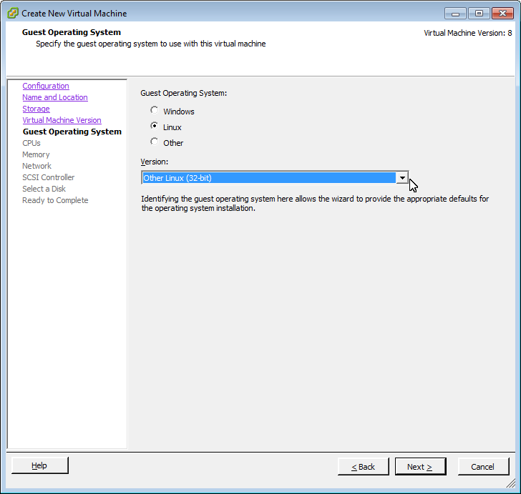

1. **CPUs**

In the CPUs pane select keep “Number of virtual sockets” set to “1” and set “Number of Cores per virtual socket” to 2 then click “Next”

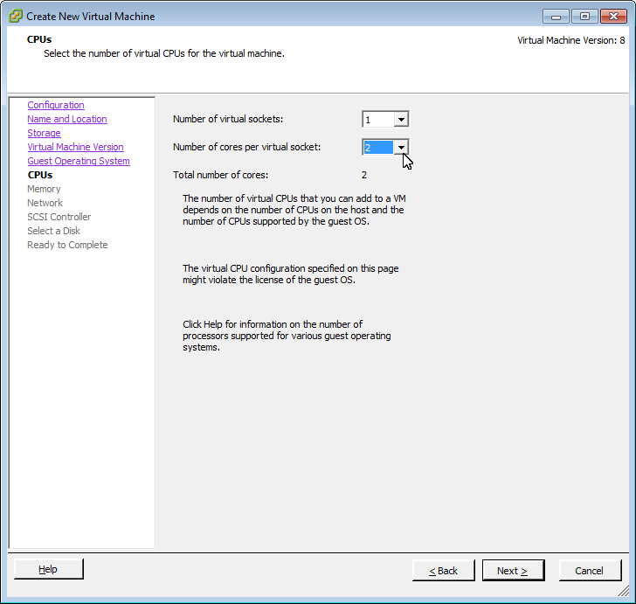

1. **Memory**

Click “Next” to keep the default memory size of 256 MB

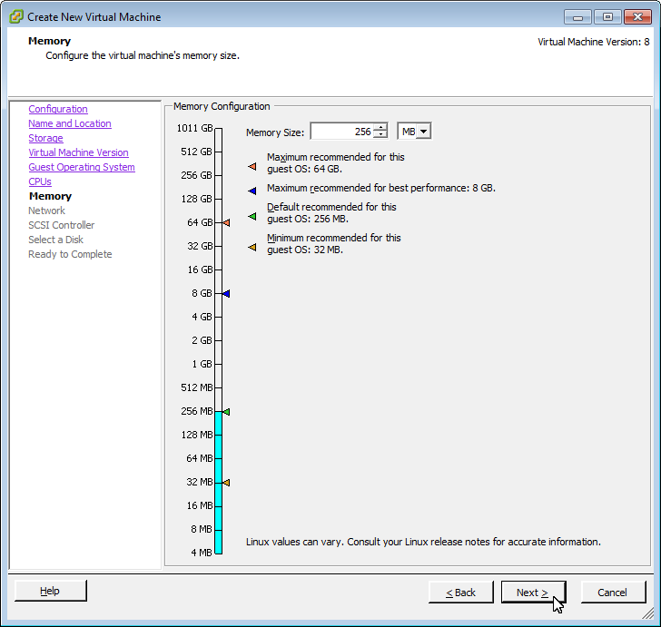

1. **Network**

In the “Create Network Connections” pane select up to 4 (minimum 2) from the “How many NICs do you want to connect” pull down menu, set adapter type to “E1000” for all NICs, deselect “Connect at Power On” option for NICs 2 and above and then click “Next”

|  |
| --- |
| Note |
| An additional six virtual NICs can be added after the virtual machine is created by editing the VMs configuration or by using the “Edit the virtual machine settings before completion” option in the wizard. See the “Network Configuration” section for instructions. |

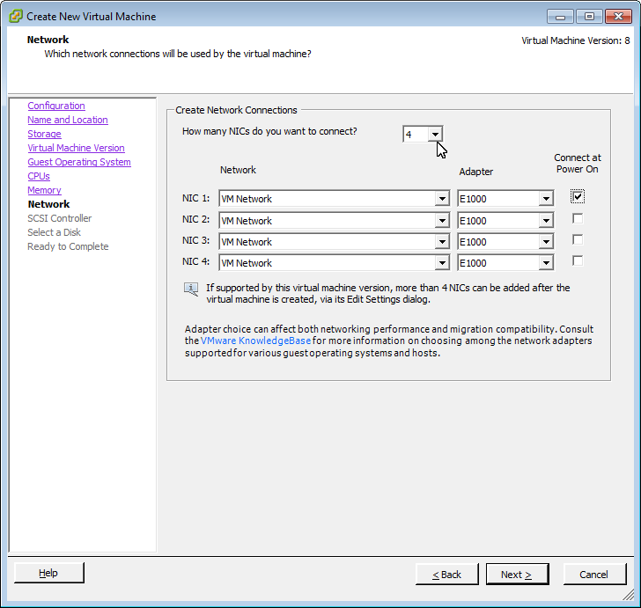

1. **SCSI Controller**

Click “Next” to accept the default “LSI Logic Parallel” SCSI controller type

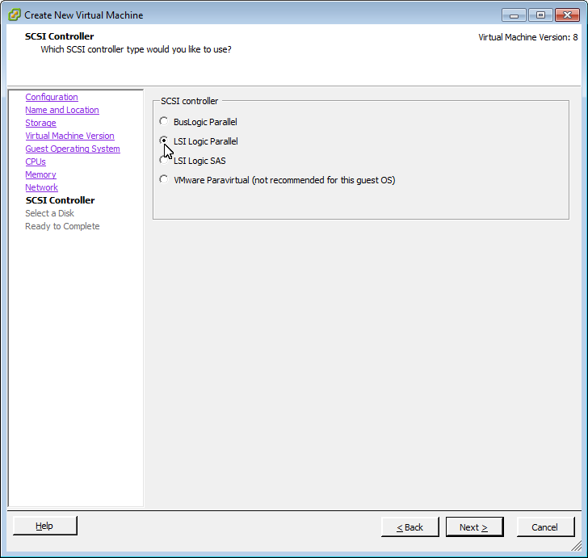

1. **Select a Disk**

Click “Next” to accept the default “Create a new virtual disk” option

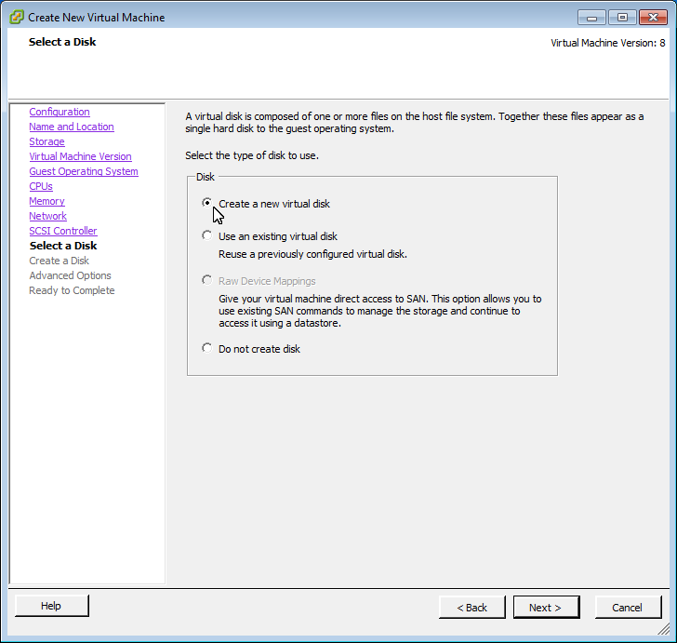

1. **Create a Disk**

Set “Disk Size” to 256 MB by entering “256” in the numerical field and selecting “MB” from the pull down option then click “Next”

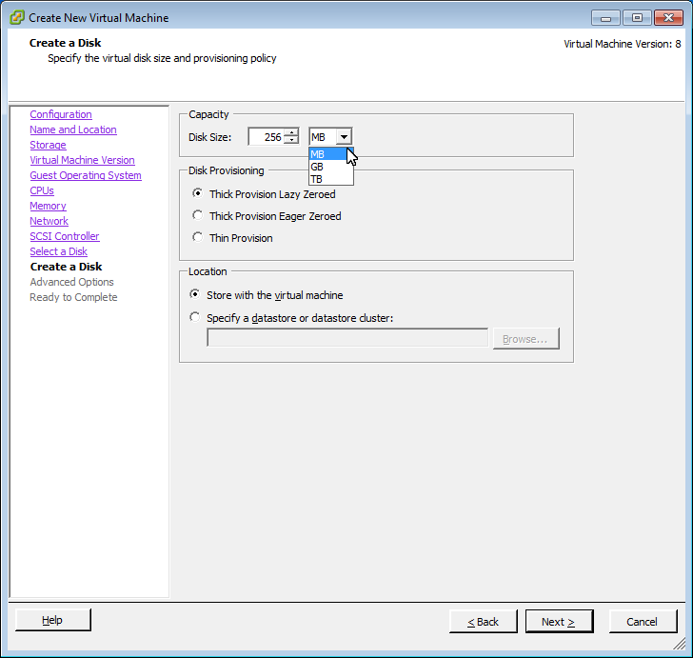

1. **Advanced Options**

Under the “Virtual Device Node” pane select “IDE (0:0)” and then click “Next”

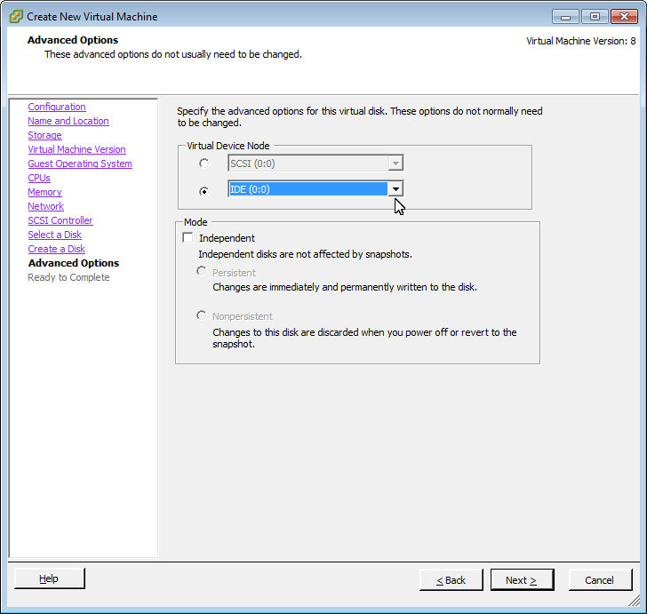

1. **Ready to Complete**

Review the settings for the new virtual machine then click “Finish”

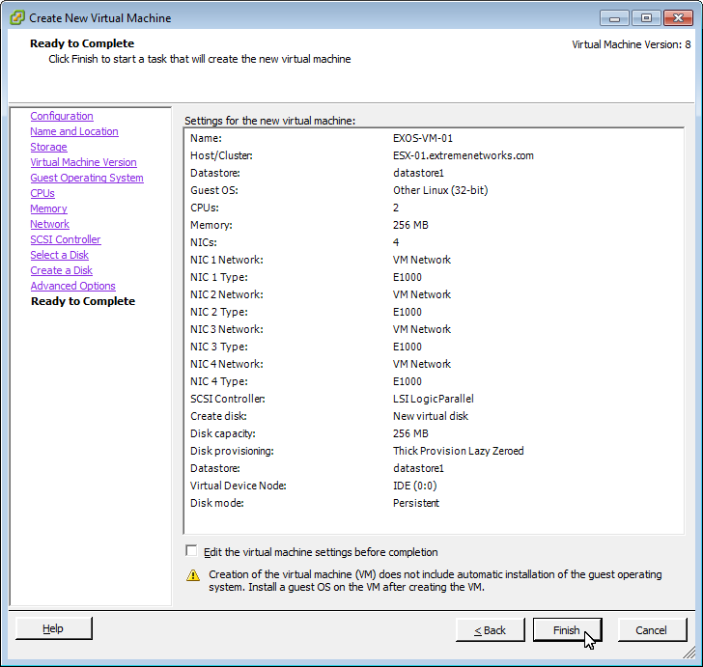

1. **Upload EXOS ISO**
2. From the Inventory view in vSphere Client select the host then in the “Configuration” tab select “Storage” from the “Hardware” pane

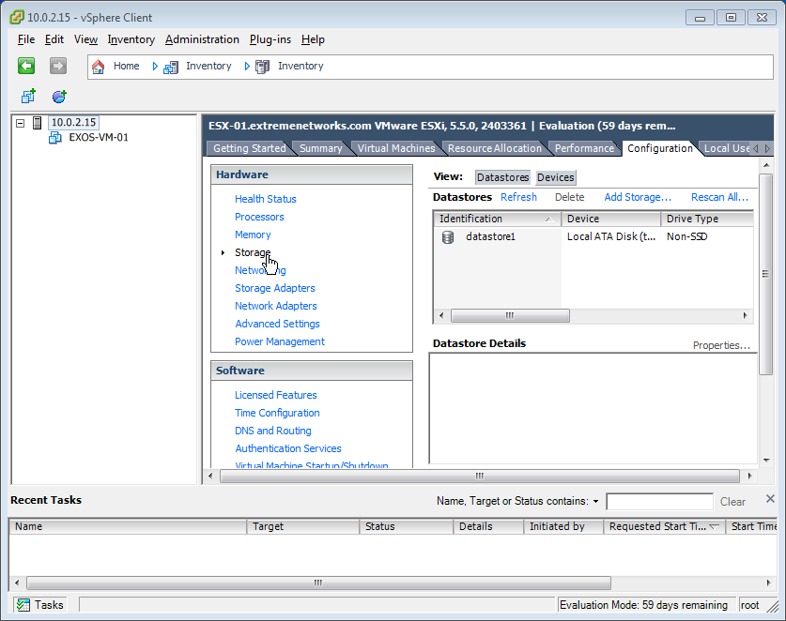

1. In the “Storage” pane right click on a datastore where the EXOS image will be uploaded and then select “Browse Datastore”

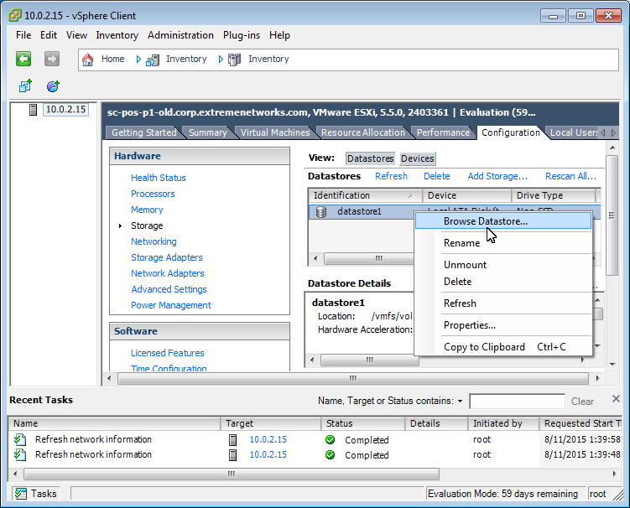

1. Click on the Upload to Datastore icon and select “Upload File”

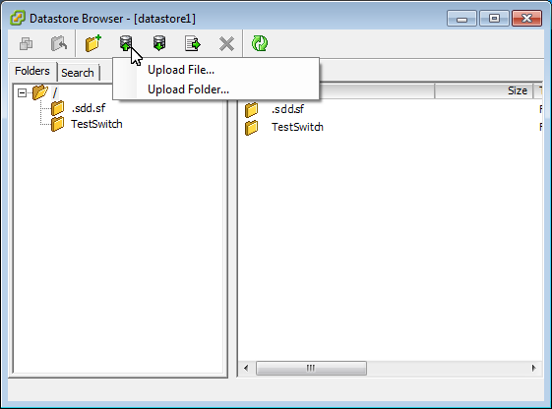

1. Browse to and Select the EXOS ISO file to be installed on the VM, then click open to upload the file to the datastore

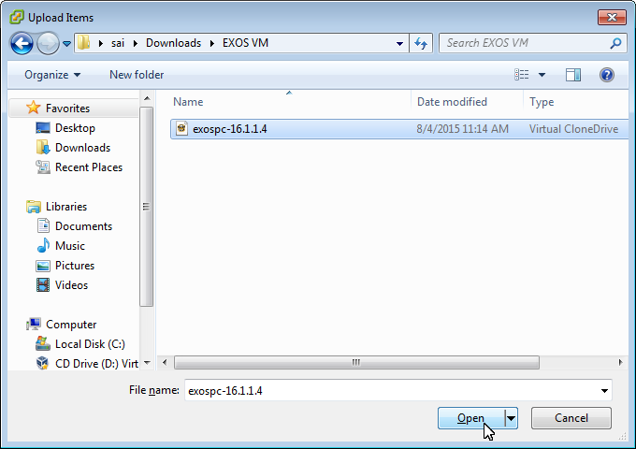

1. **Connect to ISO image**
2. From the vSphere Client inventory view right-click on the EXOS VM and select “Edit Settings”

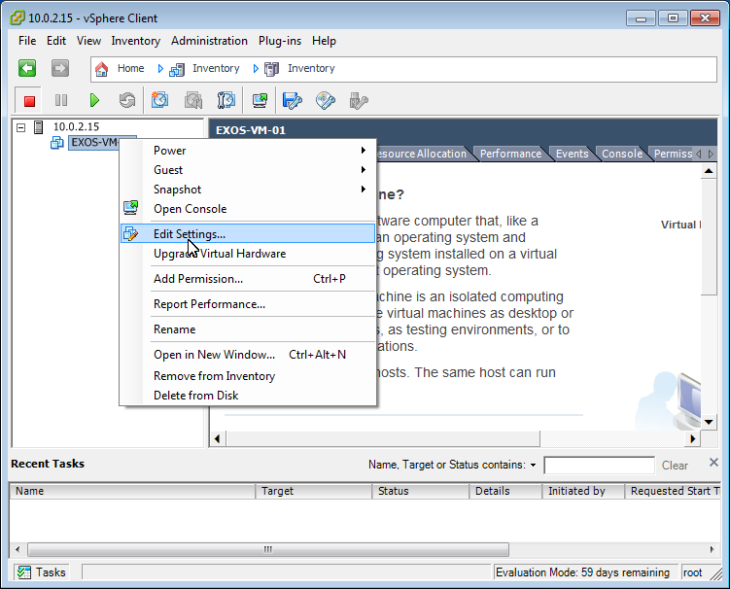

1. In the “Hardware” tab select “CD/DVD drive 1” , in the “Device Status” pane select “Connect at power on”, in the “Device Type” pane select “datastore ISO File” then click on “Browse”

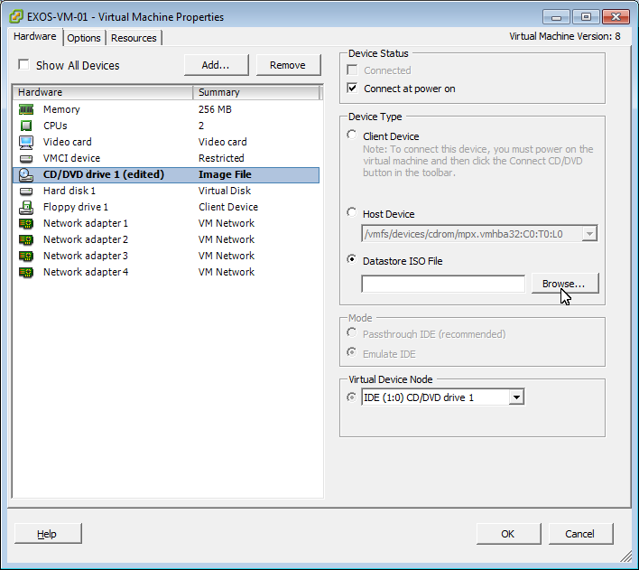

1. Double-click on the datastore where the EXOS ISO was uploaded

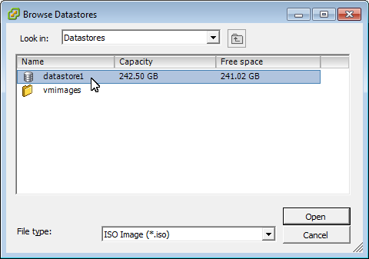

1. Select the EXOS ISO file and then click “OK”

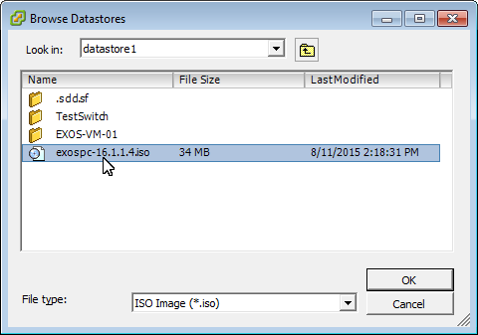

1. Click “OK” to close the “Virtual Machine Properties” window
2. **Power On EXOS VM**
   1. From the vSphere Client inventory view select the EXOS VM and click on the “Launch Virtual Machine Console” icon

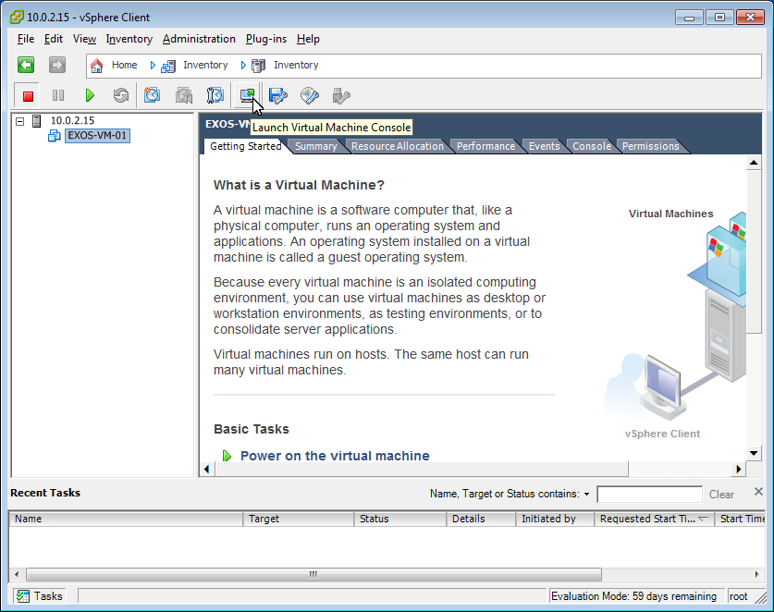

* 1. Click the “Power On” icon to power on the EXOS VM

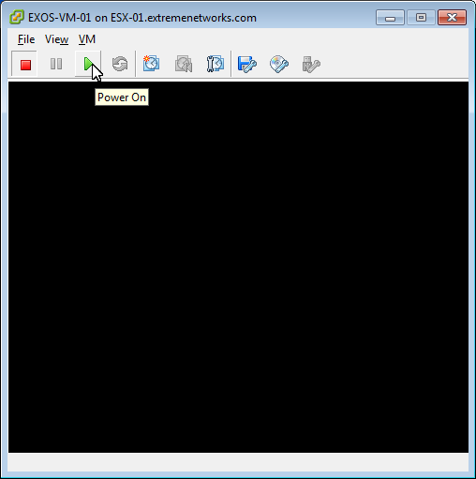

1. **Install EXOS**

In the VM console window enter “Y” at the “Ok to continue” prompt to initiate EXOS installation

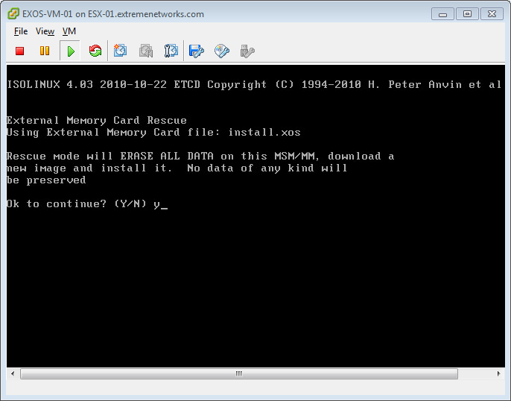

1. **Disconnect EXOS ISO**

Once installation is completed click on the “Connect/disconnect the CD/DVD devices of the virtual machine” to disconnect the EXOS ISO image

|  |
| --- |
| Note |
| To release the cursor from within the VM console press CTRL + ALT |

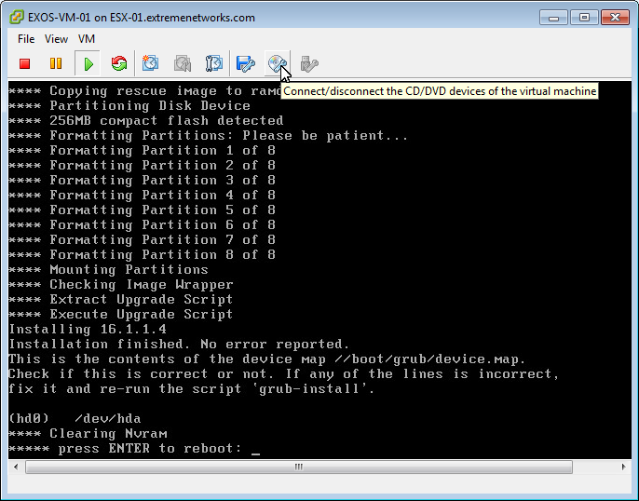

1. **Reboot the VM**

Press enter within the VM console to reboot and complete installation

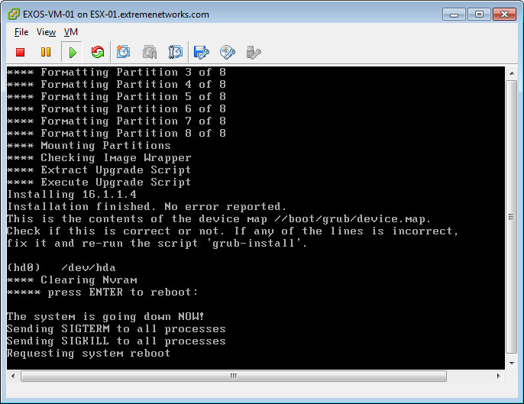

1. **Verify Install**
   1. Confirm successful installation by logging in to the switch using the factory default credentials:

*User = admin*

*Password: <null>*

|  |
| --- |
| Note |
| A “*(pending-AAA) login*:” prompt is displayed on the switch console while the switch is completing the boot up process. You must wait for the following message to be displayed in order to log into the switch:  “*Authentication Service (AAA) on the master node is now available for login”* |

|  |
| --- |
| Note |
| A “No such file or directory” error message may be appear on the console during bootup. The error is similar to the following:  “*/dev/extr/local/flashb: No such file or directory*  *[ 25.180000] coreDumpWrite(0, cc9f7ed8, 8) failed, -1”*  This message will not affect the EXOS switch operations and can be ignored |

When you boot up the switch for the first time the “Safe Defaults” interactive script will run. Answer the questions to configure management access for enhance security.

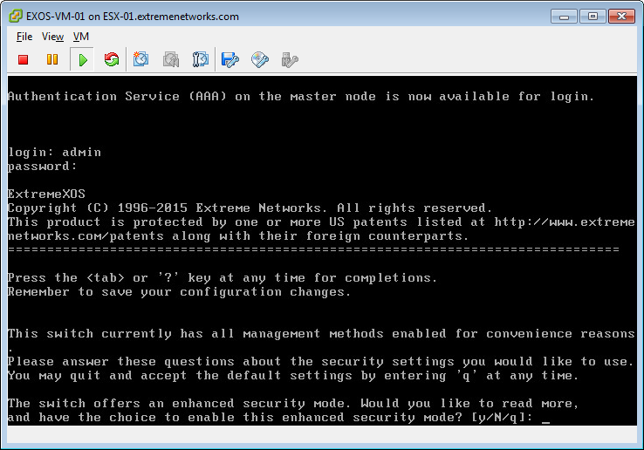

* 1. At the switch prompt type “show ports no-refresh” to verify that the switch displays the 3 front-side ports that where created in the previous steps

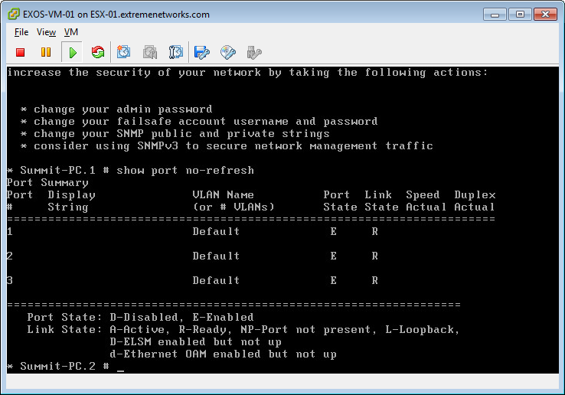

**EXOS VM ESXi Network Configuration**

An EXOS virtual machine running on an ESXi host supports one virtual out-of-band management Ethernet port and up to nine virtual front-panel Ethernet ports. The first VM network adapter (Network adapter 1) always maps to the virtual management port. The additional VM network adapters map sequentially to the “front–panel” ports on the EXOS VM (e.g.. Network adapter 2>port 1, Network adapter 3-> port 2, etc). The first four virtual NICs (Mgmt port and switch port 1-3) can be can be added when using the “Create New Virtual Machine” wizard. If needed, additional virtual NICs can be added after the Virtual machine is created by editing the VMs configuration or by using the “Edit the virtual machine settings before completion” option in the wizard.

|  |
| --- |
| Note |
| In order for the front-panel ports to accept all traffic they must be enabled for promiscuous mode |

Each of the VMs network adapter is configured to be connected to a virtual switch (vSwitch) using port groups. This virtual connection provides Ethernet connectivity to virtual and physical networks.

A common configuration is to connect the VMs Network Adapter 1 (out-of-band Mgmt port) to a VM port group and vSwitch that is mapped to a physical adapter (referred by VMware as “vmnic”) on the ESXi host. This allows direct telnet access to the EXOS VM via the management port IP address and additional switch management tasks such as EXOS upgrades and configuration uploads and downloads directly to external network devices.

The remaining VM network adapters, which map to the front-panel ports, are then configured to use VM port groups using an Internal vSwitches. An internal vSwitch is a vSwitch with no physical network mapped to it. All network connectivity remains within the VM and Vswitch. Only other VMs that ae mapped to the same “internal” vSwitch can communicate with each other. Separate EXOS VMs can be interconnected by using the same vSwitch creating a direct virtual point-to-point link. The VM network adapters can also be configured to use internal networks to connect other types of client and server VMs or physical devices using a vSwitch mapped to a vmnic.

Things to Note:

* Each VM network adapter maps to one port on the switch
* The first VM network adapter always maps to the out-of-band Mgmt port
* All VM network adapters need to be configure as “E1000” type
* Adding EXOS VM network adapters to the same internal network can create loops. Create and use unique port groups and vSwitches for each VM network adapter. (Exceptions include interconnecting EXOS VMs which need to use the same port group and port load-sharing}
* To interconnect two or more EXOS VM switches configure a virtual network adapter on each EXOS VM to use the same port group
* The “connect” setting in the VM network adapter settings can be toggled to “connect” and “disconnect” the virtual link on the associated port
* Prior to the initial configuration of the switch, uncheck the “Connect at power on” option for the front-side ports’ VM network adapters in the VMs hardware settings. This avoids potential loops as the factory default configuration includes all front-side ports as members of the “Default” VLAN

|  |
| --- |
| * Note |
| Detailed information on ESXi network configuration can be in the “vSphere Networking Guide” located on VMware’s documentation site:  <https://www.vmware.com/support/pubs/vsphere-esxi-vcenter-server-pubs.html> |

**Create additional VM Network Adapters**

In previous steps four VM network adapters where created using the “Create New Virtual Machine Wizard” which provides one out-of-band management port and three front-side ports on the EXOS VM switch. This section steps through instructions for creating additional VM network adapters for additional switch ports. This section can be skipped if no additional ports are needed.

1. **Edit VM settings**

From the vSphere Client inventory view right-click on the EXOS VM and select “Edit Settings”

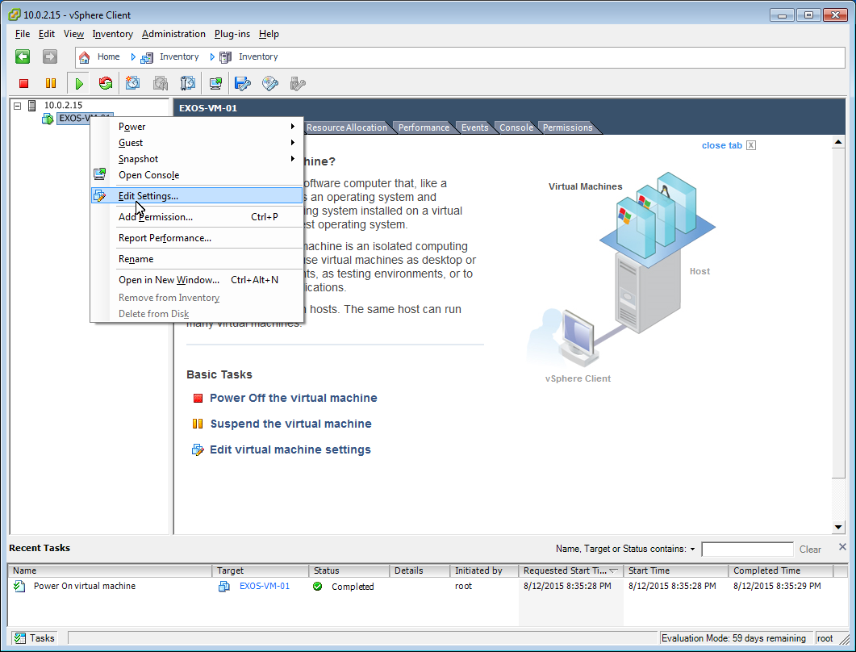

1. **Add hardware**

In the “Virtual Machine Properties” hardware tab click “Add”

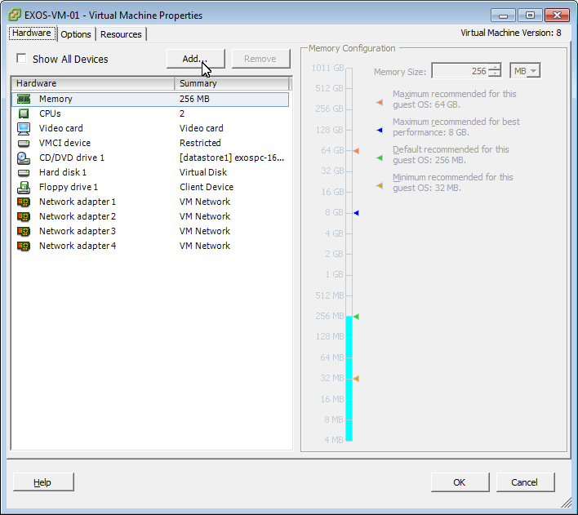

1. **Device Type**

In the “Choose the type of device you wish to add” pane select “Ethernet Adapter” and then click “Next”

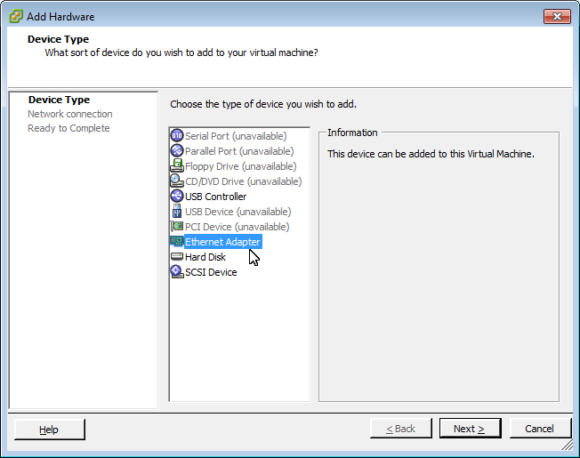

1. **Network Type**

From the “Adapter Type” pull down menu select E1000 and in the “Device Status” pane uncheck “Connect at power on” then click “Next”

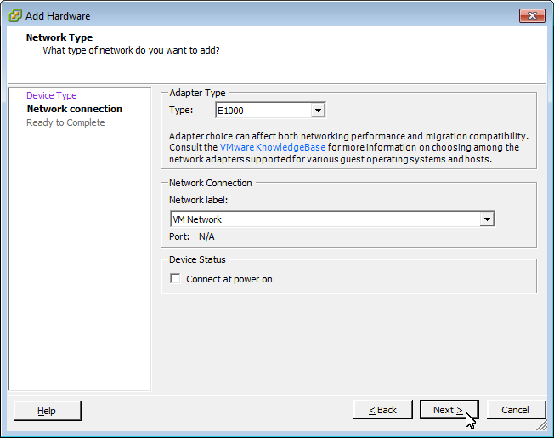

1. **Ready to Complete**

Review the hardware option settings then click “Finish”

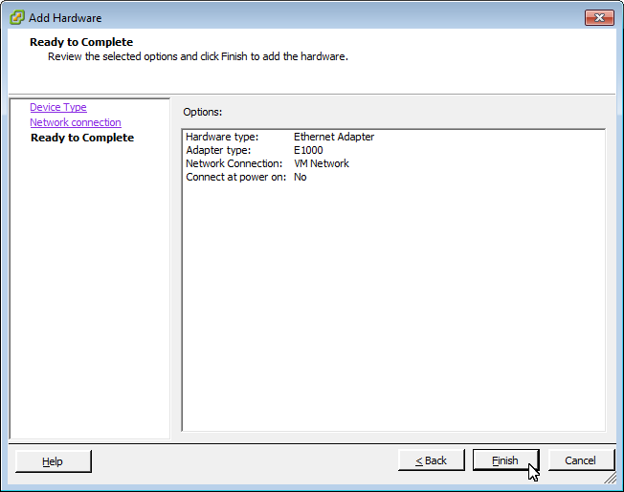

1. Repeat steps 1-5 to create up to 5 additional VM Network adapters (up to a total of 10 per EXOS VM) then click “OK” to close the “Virtual Machine Properties” window

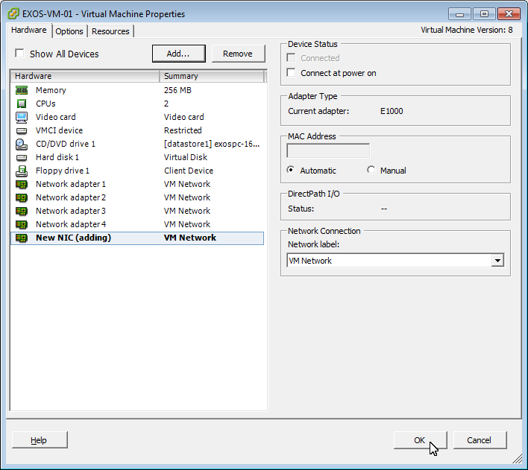

1. **Reboot EXOS VM**

In the VM console window type “Reboot” to reboot the EXOS VM in order for EXOS to recognize the added VM Network Adapter(s) as additional ports

**Create VM Port Groups and vSwitches**

1. **Add Networking**

From the Inventory view in vSphere Client select the host then in the “Configuration” tab select “Networking” from the “Hardware” pane and the click on “Add Networking”

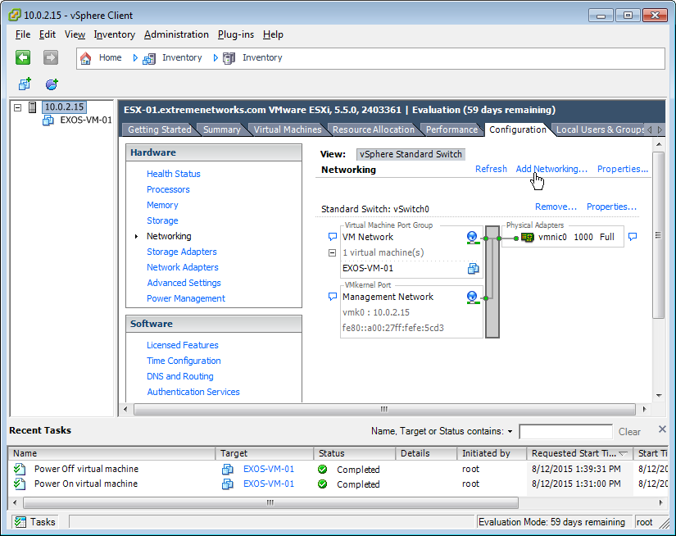

1. **Connection Type**

Click “Next” to accept the default “Virtual Machine” Connection Type option

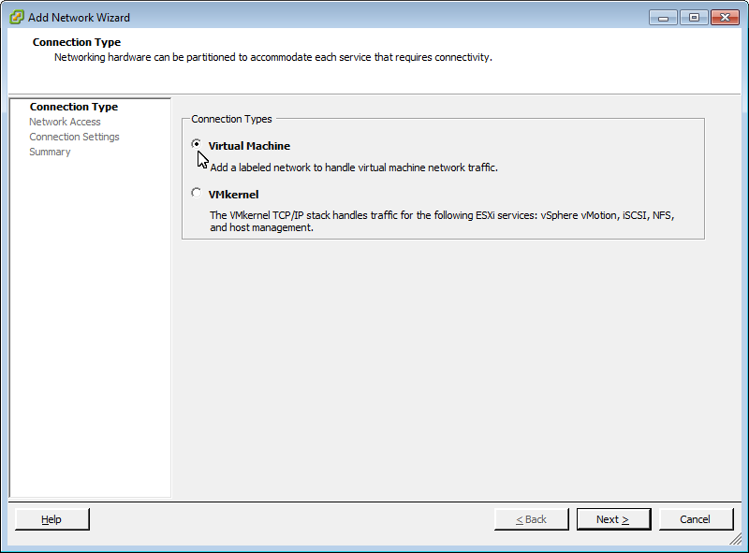

1. **Virtual Machines – Network Access**

Click “Next” to accept the default “create a vSphere standard switch” option

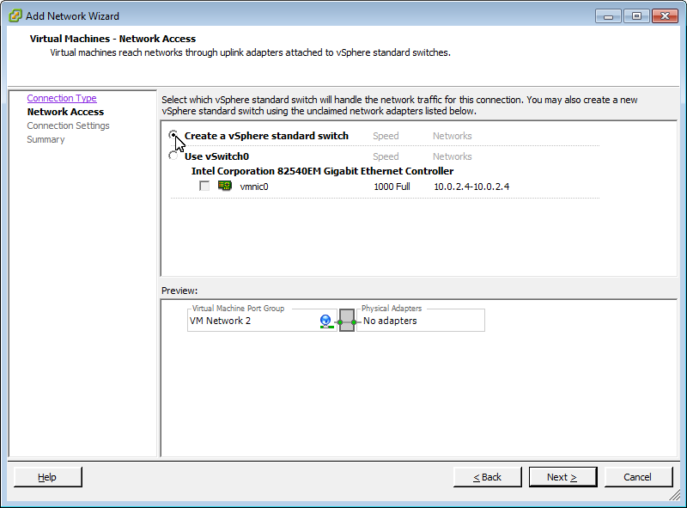

1. **Virtual Machine – Connection Settings**

In the “Port Group Properties” pane edit the “Network Label” field with a descriptive name for this port group, select “All (4095)” from the “VLAN ID” pulled down menu then click “Next”

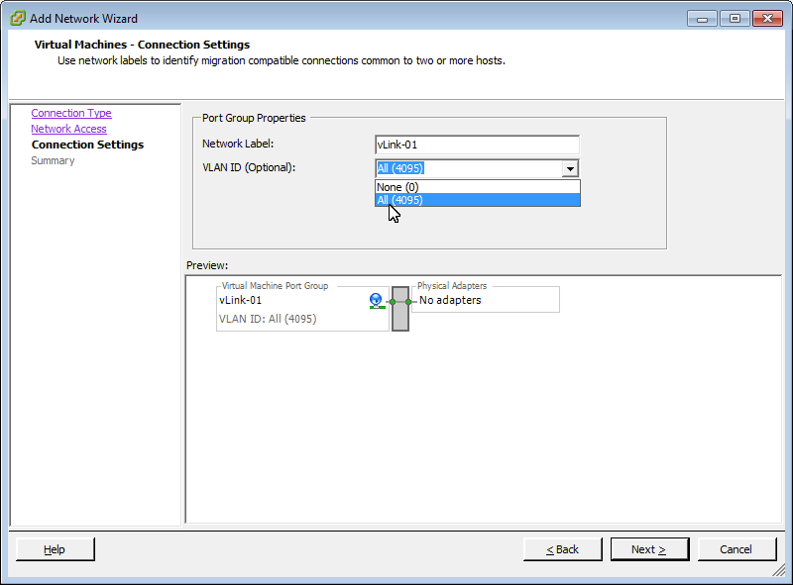

1. **Ready to Complete**

Review the settings then click “Finish”

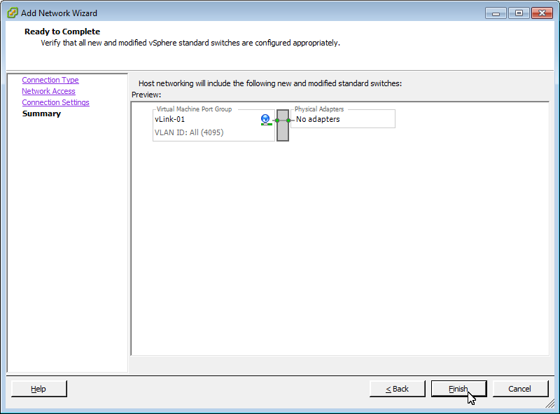

Repeat steps 1-5 to create additional VM port group/vSwitches up to the desired number of front-panel switch ports (up to 9)

**Configure Port Groups for Promiscuous Mode**

|  |
| --- |
| Note |
| Promiscuous Mode only needs to be enabled on VM Port Groups that will map to the switches front-side ports. Do not enable it on the out-of-band management ports VM Port Group |

1. **Edit vSwitch Properties**

From the Inventory view in vSphere Client select the host then in the “Configuration” tab select “Networking” from the hardware pane and the click on “Properties” on the an Internal vSwitch that was created for use by the EXOS VM

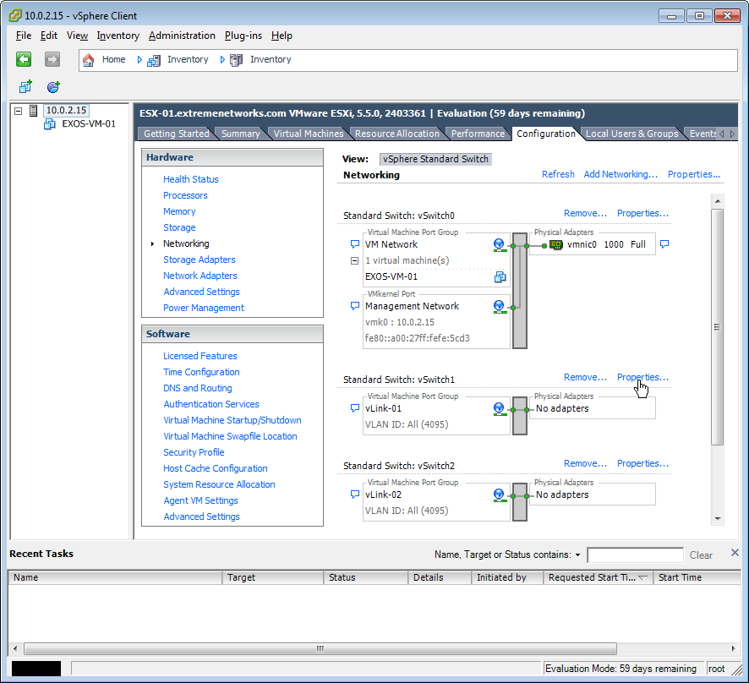

1. **Edit VM Port Group**

In the “Ports” tab of the vSwitch properties window select the VM Port Group and then click “Edit”

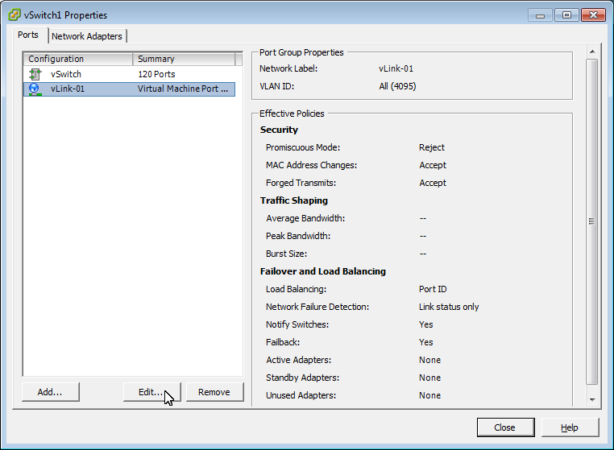

1. **VM Port Group Security Exceptions**

In the VM Port Group properties window Select the “Security” tab, select the “Promiscuous Mode” checkbox then from the pull down menu select “Accept” and click “OK”

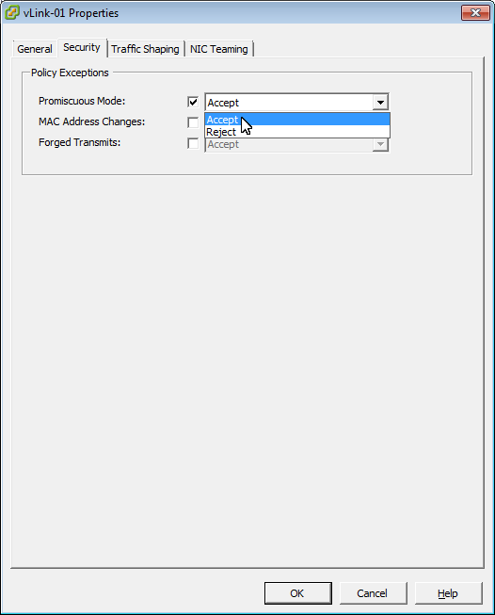

1. In the “Effective Policies” pane of VM Port Group window verify that “Promiscuous Mode” is set to “Accept” then click “Close”

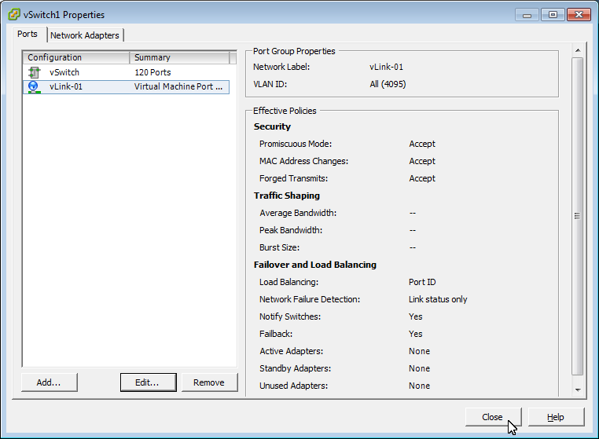

Repeat steps 1-4 for all VM port groups that will be used for EXOS VM front-side ports

**Map VM Network Adapters to Port Groups**

1. **Edit VM settings**

From the vSphere Client inventory view right-click on the EXOS VM and select “Edit Settings”



1. **Network Connection – Network label**

In the “Virtual Machine Properties” Hardware tab select “Network Adapter 2” then using the “Network label” pull down menu select a port group

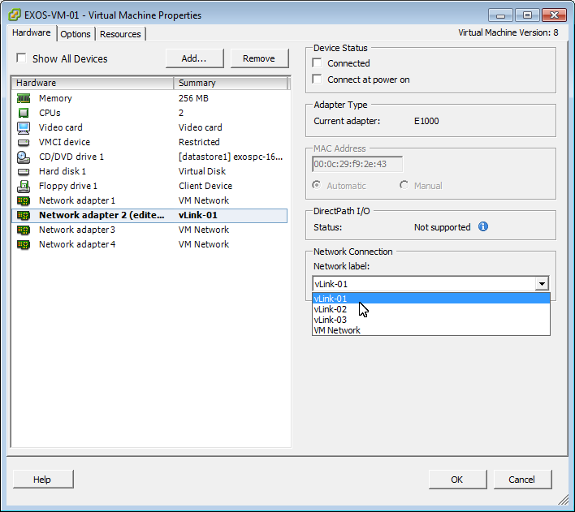

1. Repeat steps 1-2 to map the remaining VM Network Adapters then click “OK”

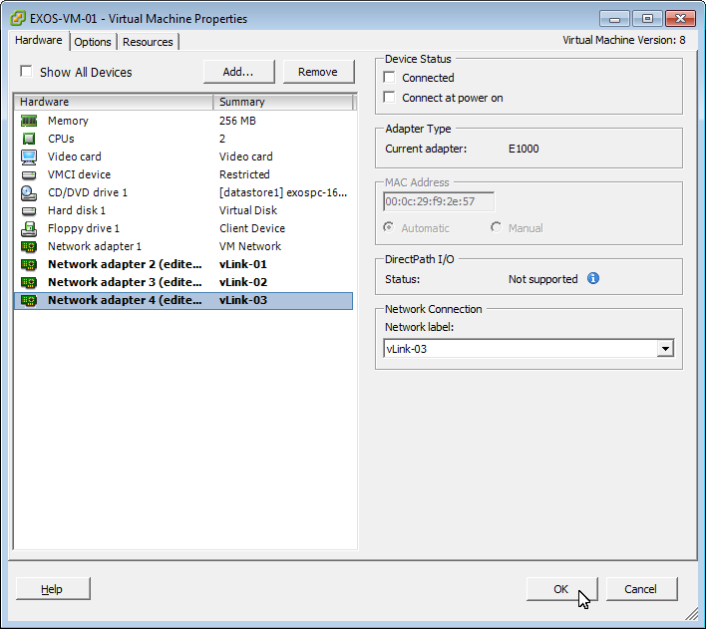

The EXOS VM is now ready to be configured and used similar to an Extreme Networks physical Summit switch. Remember to select “Connected” and “Connect at power on” for the Network adapters that you want the port links active after configuring the switch.

Additional EXOS VMs can be created by creating a New VM and repeating all steps or by cloning or copying the VM. However if VM is cloned the VM Network adapters will be mapped to the same Port Groups as the original VM. Create and configure new Port Groups/vSwitches as needed for use by the new VM.

# Terms & Condition of Use

Extreme Networks Networks, Inc. reserves all rights to its materials and the content of the materials.  No material provided by Extreme Networks Networks, Inc. to a Partner (or Customer, etc.) may be reproduced or transmitted in any form or by any means, electronic or mechanical, including photocopying and recording, or by any information storage or retrieval system, or incorporated into any other published work, except for internal use by the Partner and except as may be expressly permitted in writing by Extreme Networks Networks, Inc.

This document and the information contained herein are intended solely for informational use. Extreme Networks Networks, Inc. makes no representations or warranties of any kind, whether expressed or implied, with respect to this information and assumes no responsibility for its accuracy or completeness. Extreme Networks Networks, Inc. hereby disclaims all liability and warranty for any information contained herein and all the material and information herein exists to be used only on an "as is" basis. More specific information may be available on request. By your review and/or use of the information contained herein, you expressly release Extreme Networks from any and all liability related in any way to this information.   A copy of the text of this section is an uncontrolled copy, and may lack important information or contain factual errors. All information herein is Copyright ©Extreme Networks Networks, Inc. All rights reserved. All information contain in this document is subject to change without notice.

For additional information refer to: [http://www.Extreme Networks.com/constants/terms-of-use.aspx](http://www.enterasys.com/constants/terms-of-use.aspx)